**23**

**Continuous Charge Distributions and Gauss’s Law**

|  |
| --- |
| **CHAPTER OUTLINE** |

23.1 Electric Field of a Continuous Charge Distribution

23.2 Electric Flux

23.3 Gauss’s Law

23.4 Applications of Gauss’s Law to Various Charge Distributions

* An asterisk indicates a question or problem new to this edition.

|  |
| --- |
| **SOLUTIONS TO THINK-PAIR-SHARE AND ACTIVITIES** |

**\*TP23.1** **Conceptualize** Consider the illustration of the positive charge cloud in Figure 23.14b. The electron, initially at the center of the cloud is pulled out to a position a distance *r* from the center and released.

**Categorize** The electron is modeled as a *particle in a field (electric)*.

**Analyze**  (a) Using the particle in an electric field model and the result from part (b) of Example 23.6, we can find the force on the electron in the radial direction:

(1)



This force is of the form of Hooke’s law, with an effective spring constant of *k* = *kee*2/*a*3. Therefore, if this is the only force on the electron, it will exhibit simple harmonic motion.

(b) From Equation 15.14, the frequency of oscillation will be

(2)



(c) Solve Equation (2) for the cloud radius *a*:

(3)



Substitute numerical values:



(d) Yes; with some online research, you can find that the result in part (c) is indeed consistent with the size of the hydrogen atom, which led many to believe in the Thomson model.

**Finalize** Later analysis showed that the Thomson model was not consistent with other measurements of the hydrogen atom, and it was replaced in 1913 with the Bohr model. We will discuss both these models in Chapter 41.

*Answers:* (b) (c) (d) yes



**\*TP23.2** **Conceptualize** Be sure you understand the physical situation: Because of surface tension, the water remains in a closed shape. Because of the effective absence of gravity, there is no preferred direction and the closed shape is a sphere. Because water is continuously being supplied at the center of the sphere of water, the entire sphere is expanding outward.

**Categorize** Water is an incompressible fluid. Therefore, we will apply the equation of continuity for fluids (Eq. 14.7) to this collection of water.

**Analyze** (a) The equation of continuity for fluids tells us that the volume flow rate of water must be the same through all spherical surfaces concentric with the the point at the end of the tube, where the flow rate is *IV*. Imagine a spherical surface of radius *r* centered on the end of the tube. From the equation of continuity for fluids,

(1)



Keep in mind that the velocity of every bit of water is radially outward. Solving for the speed of the water,

(2)



*IV* is the flow rate of water at the end of the tube, which must be the same everywhere, including through the area *A* of the sphere. Therefore, substitute for the area of the sphere:

(3)



(b) The diagram appears below:

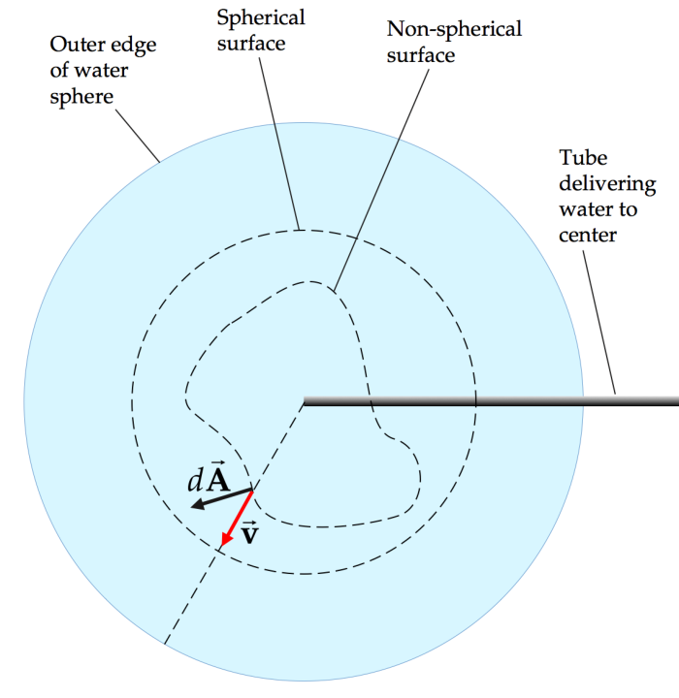

(c) From Equation (1), write an equation for the incremental amount of water flowing through the small area:

(4)



where is the projection of the magnitude of the area element *dA* onto a radial direction. If the angle between and is **, then



(5)



and Equation (4) becomes

(6)



Using the definition of the scalar product, Equation (6) can be written

(7)



Integrate Equation (7) over the entire nonspherical surface:

(8)



(d) Compare this Equation to Gauss’s law, Equation 23.7:

(9)



The equations have the same form! In Equation (9), is the electric field, with which we are becoming familiar in this chapter. Its analog in Equation (8) is the water velocity field . On the left in Equation (9) is a quantity that includes the source of the electric field, *q*in. On the left in Equation (8) is also a source, that of the water velocity field: the rate *R* at which water is leaving the end of the tube. Increase *q*in, and you obtain a stronger electric field. Increase *IV*, and you obtain higher magnitudes of the velocity vectors.



**Finalize**  Notice that the dashed lines in our figure represent the intersection with the page of “gaussian surfaces” for the water velocity field. While there are many analogs between the water velocity field and the electric field in this discussion, there are some places where the analogy breaks down. The water velocity field is constrained within a finite “water space” with a spherical boundary: the sphere of water. The electric field exists throughout space. The water space is expanding and growing in size. The space in which the electric field exists is fixed in size and has no sense of expansion.

*Answers:* Answers will vary.

|  |
| --- |
| **SOLUTIONS TO END-OF-CHAPTER PROBLEMS** |

Section 23.1 Electric Field of a Continuous Charge Distribution

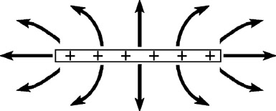

**ANS. FIG. P23.1**

**P23.1** The field lines are shown in ANS. FIG. P23.1, where we’ve followed the rules for drawing field lines where field lines point toward negative charge, meeting the rod perpendicularly and ending there.

**P23.2** For the positively charged disk, a side view of the field lines, pointing into the disk, is shown in ANS. FIG. P23.2.

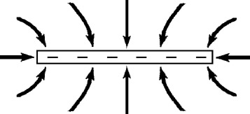

**ANS. FIG. P23.2**

**P23.3** We may particularize the result of Example 23.2 to



where we choose the *x* axis along the axis of the ring. The field is parallel to the axis, directed away from the center of the ring above and below it.

(a) At *x* = 0.010 0 m,



(b) At *x* = 0.050 0 m,



(c) At *x* = 0.300 m,



(d) At *x* = 1.00 m,



**P23.4** The electric field at a distance *x* is



This is equivalent to



For large *x*, and



so



Substitute ,



But for , , so



**P23.5** (a) From Example 22.3,



here,



the electric field is then



(b) The near-field approximation gives:



(c) The electric field at this point is



(d) With this approximation, suppressing units,



**P23.6** (a) The electric field at point *P* due to each element of length *dx* is and is directed along the line joining the element to point *P*. The charge element *dq* = *Qdx*/L. The *x* and *y* components are

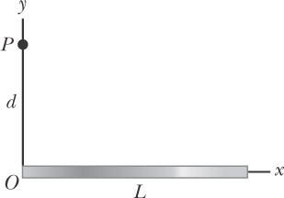

**ANS. FIG. P23.6**



where



and

where



Therefore,



and



(b) When *d* >> *L*,



and



**P23.7** (a) Magnitude , where



(b) The charge is positive, so the electric field points away from its source,



**P23.8** (a) The electric field at point *P,* due to each element of length *dx*, is and is directed along the line joining the element to point *P*. By symmetry,

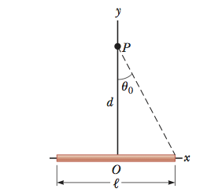

**ANS. FIG. P23.8**



and since



where



Therefore,



with



(b) For a bar of infinite length, and



**P23.9** (a) We define *x* = 0 at the point where we are to find the field. One ring, with thickness *dx*, has charge and produces, at the chosen point, a field



The total field is



integrating,



(b) Think of the cylinder as a stack of disks, each with thickness *dx*, charge , and charge-per-area . One disk produces a field



So,



**Section 23.2 Electric Flux**

**P23.10** The electric flux through the bottom of the car is given by



**P23.11** For a uniform electric field passing through a plane surface, where *θ* is the angle between the electric field and the normal to the surface.



(a) The electric field is perpendicular to the surface, so *θ* = 0°:



(b) The electric field is parallel to the surface: *θ* = 90°, so cos*θ* = 0, and the flux is



P23.12 We are given an electric field in the general form

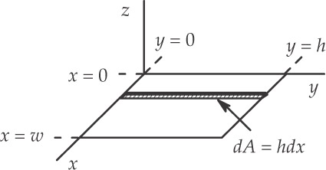

**ans. Fig. P23.12**



In the *xy* plane, *z* = 0 so that the electric field reduces to



To obtain the flux, we integrate (see ANS. FIG. P23.12 for the definition of *dA*):



Where the term was eliminated since



**Section 23.3 Gauss’s Law**

**P23.13** The electric flux through the hole is given by Gauss’s Law (Equation 23.7) as



**P23.14** The gaussian surface encloses the +1.00-nC and –3.00-nC charges, but not the +2.00-nC charge. The electric flux is therefore



**P23.15** The electric flux through each of the surfaces is given by .



Flux through S1:



Flux through S2:



Flux through S3:



Flux through S4:



**P23.16** The total flux through the surface of the cube is



(a) By symmetry, the flux through each face of the cube is the same.



(b)



(c)



**P23.17** (a) The gaussian surface encloses a charge of +3.00 nC.



(b)



**P23.18** (a) The total electric flux through the surface of the shell is



(b) Through any hemispherical urface of the shell, by symmetry,



(c) , the same number of field lines will pass through each surface, no matter how the radius changes.



**P23.19** The total charge is . The total outward flux from the cube is of which one-sixth goes through each face:



**P23.20** The total charge is *.* The total outward flux from the cube is of which one-sixth goes through each face:



**P23.21** (a) One-half of the total flux created by the charge *q* goes through the plane. Thus,



(b) The square looks like an infinite plane to a charge *very close* to the surface. Hence,



(c)



**P23.22** (a)



(b) The electric field through the curved side of the cylinder is zero because the field lines are parallel to that surface and do not pass through it. The electric field lines pass outward through the ends of the cylinder, so both have a positive flux. Because the field is uniform, the flux is *πR*2*E* for each end.



(c) The net flux is positive, so the charge in the cylinder is positive. To be a uniform field, the field lines must originate from a plane of charge. The net charge inside the cylinder is positive and is distributed on a plane parallel to the ends of the cylinder.

**P23.23** For uniform electric field lines passing through a flat surface, the electric flux is , where *θ* is the angle between the electric field vector and the normal to the surface.



(a)



(b) The normal points to the right; the angle between the electric field and the normal is 90° + *θ*:



(c) The normal points downward in the figure, the angle between the electric field and the normal is 180° – *θ*:



(d) The normal points to the left; the angle between the electric field and the normal is 90° – *θ*:



(e) The normal points in or out of the page; the angle between the electric field and the normal is 90°:



(f)



(g)



**Section 23.4 Application of Gauss’s Law to Various Charge Distributions**

P23.24The charge distributed through the nucleus creates a field at the surface equal to that of a point charge at its center: .



away from the nucleus



**P23.25** The distance between centers is Each produces a field as if it were a point charge at its center, and each feels a force as if all its charge were a point at its center.



P23.26 Consider two balloons of diameter 0.200 m, each with mass 1.00 g, hanging apart with a 0.050 0 m separation on the ends of strings making angles of 10.0° with the vertical.

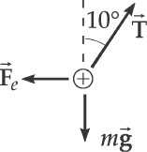

**ans. Fig. P23.26**

(a)



so



(b) The charge on each balloon can be found from



(c)



(d) The electric flux created by each balloon is



**P23.27** For a large uniformly charged sheet, will be perpendicular to the sheet, and will have a magnitude of



so



P23.28 (a) The charge per unit area of the wall is



The electric field at a distance of 2.00 cm is then



(b)



P23.29The approximation in this case is that the filament length is so large when compared to the cylinder length that the “infinite line” of charge can be assumed.

(a) We have



where the linear charge density is



so



(b) We can find the flux by multiplying the field and the lateral surface area of the cylinder:



so



*P23.30 **Conceptualize** Imagine surrounding the sphere in Figure 23.14 with an insulating shell, concentric with the sphere.

**Categorize** This problem can be argued from our understanding of Gauss’s law.

**Analyze** (a) If the electric field external to the shell is to be zero, the charge on the shell must be –*Q*, so that the total charge enclosed by a gaussian surface outside the shell encloses zero net charge.

(b) Yes, if the field external to the shell is to be zero, the sphere must be at the exact center of the shell. If the sphere is not at the center, the *flux* through a gaussian surface surrounding the shell will be zero, but the *electric field* outside the shell will not be zero. Imagine that the shell is moved so that the charged sphere is away from the center of the shell. The average position of the negative charge distribution on the nonconducting shell is still at the center of the shell, while the positive charge is some distance away from the center. Therefore, there will be an effective dipole moment for the sphere-shell combination. And, as we know, an electric dipole has an electric field surrounding it. Therefore, the shell placed around a sphere not at the center of the shell will *reduce* (because the field will fall off as 1/*r*3, as discussed in part (C) of Example 22.6), but not *eliminate* the electric field for your colleagues.

**Finalize** This problem requires a good understanding of Gauss’s law and the difference between electric flux and electric field. For a gaussian surface surrounding zero net charge, the electric *flux* is zero, but the electric *field* may not be zero.

*Answers:* (a) –*Q* (b) yes

P23.31If *ρ* is positive, the field must be radially outward. Choose as the gaussian surface a cylinder of length *L* and radius *r*, contained inside the charged rod. Its volume is and it encloses charge . Because the charge distribution is long, no electric flux passes through the circular end caps; . The curved surface has , and *E* must be the same strength everywhere over the curved surface.

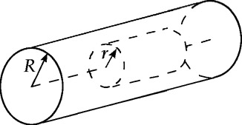

**ans. Fig. P23.31**



Gauss’s law, becomes



Now the lateral surface area of the cylinder is 2*πrL*:



Thus,



**P23.32** (a) The area of each face is *A* = 1.00 m2.

For the left face, the angle between the electric field and the normal is 0°:



For the right face, the angle between the electric field and the normal is 180°:



For the top face, the angle between the electric field and the normal is 180°:



For the bottom face, the angle between the electric field and the normal is 0°:



For the front face, the angle between the electric field and the normal is 0°:



For the back face, the angle between the electric field and the normal is 0°:



The total flux is then



(b)



(c)



P23.33 (a) At the center of the sphere, the total charge is zero, so



(b) At a distance of 10.0 cm = 0.100 m from the center,



(c) At a distance of 40.0 cm = 0.400 m from the center, all of the charge is enclosed, so



(d) At a distance of 60.0 cm = 0.600 m from the center,



The direction for each electric field is .



**P23.34** (a) The electric field is given by



Solving for the charge *Q* gives



(b) Since the charge is uniformly distributed on the surface of the cylindrical shell, a gaussian surface in the shape of a cylinder of 4.00 cm in radius encloses no charge, and .



**\*P23.35 Conceptualize** Why are the small spheres in equilibrium? They repel each other because they have the same sign. According to Gauss’s law, the electric field at radial position *r* due to the positive charge contained within a sphere of radius *r* is the same as if that charge were concentrated at the center of the sphere. The small spheres must feel an attractive force due to this effective positive charge at the center of the sphere to counteract their mutual repulsion. Therefore, the small spheres must be negatively charged.

**Categorize** Each small sphere is modeled as a *particle in equilibrium* in the horizontal direction in the figure.

**Analyze** (a) Imagine a sphere drawn in Figure P23.35, of radius *r*, where *r* is the equilibrium distance of a small sphere from the center of the large sphere. Then, according to Gauss’s law, only the charge contained within the sphere of radius *r* exerts an attractive force on the small negatively charged spheres. Because the charge distribution on the large sphere is uniform, this charge *q*in can be found from the ratio of volumes:

(1)



Now, apply the particle in equilibrium model to one of the small spheres:

(2)



The repulsive force is between the two small spheres, while the attractive force is between a small sphere and *q*in from the large sphere. Apply Coulomb’s law and then substitute into Equation (2) from Equation (1):

(3)



Solve Equation (3) for the equilibrium separation distance *r*:

(4)



(b) Now, we wish to test to see if *r* can be greater than *a*. First, let’s see if *r* can equal *a*, that is, the small spheres are just at the surface of the larger sphere:

(5)



For this particular relationship between the charges, the small spheres can be in equilibrium just at the surface of the larger sphere. Now, let’s consider points outside the larger sphere, that is, for *r* > *a*. The electric field outside the sphere, as we found from Gauss’s law, is



Therefore, Equation (2) for the forces on one of the small spheres is now written as

(6)



Equation (6) is the same as Equation (5) and we see that the radius *r* cancels out of the equation. Your conclusion to share with your research director is this: as long as the charges have the relationship expressed in Equation (6), they will be in equilibrium at *any* symmetric positions outside the sphere.

**Finalize** Notice that –*q* in equations such as Equation (4) is a positive quantity because *q* is negative.

*Answer:* (a) (b) Yes, it is possible for *any* value of *r* > *a*.



**\*P23.36 Conceptualize** Why are the small spheres in equilibrium? They repel each other because they have the same sign. According to Gauss’s law, the electric field at radial position *r* < *a* due to the positive charge contained within a cylinder of length *L* and radius *r* is the same as if that charge were concentrated uniformly along the axis of the cylinder. The small spheres must feel an attractive force due to this effective positive charge along the axis of the cylinder to counteract their mutual repulsion. Therefore, the small spheres must be negatively charged.

**Categorize** Each small sphere is modeled as a *particle in equilibrium* in the vertical direction in Figure P23.36.

**Analyze** (a) The cylindrical insulator was not studied as thoroughly as was the spherical insulator in the chapter. So we need some preliminary work. Imagine a gaussian surface in the shape of a cylinder whose axis coincides with that of the charge distribution, but whose radius is *r* < *a*. The gaussian cylinder is of length  << *L* and is centered at the center of the tunnel. Because *L* >> *a*, we assume from symmetry that the electric field vectors are perpendicular to the common axis of the cylinders. Therefore, no electric flux passes through the end caps of the gaussian cylinder. Considering the only flux to be through the curved surface of the gaussian cylinder, Gauss’s law becomes



where *V* is the volume of the gaussian cylinder. In the integral, the electric field vectors are perpendicular to the area vectors at all locations on the surface of the gaussian cylinder. Therefore,

(1)



Now, apply the particle in equilibrium model to one of the small spheres:

(2)



The repulsive force is between the two small spheres, while the attractive force is that applied on the charge *q* by the electric field due to the cylinder. Apply Coulomb’s law on the left in Equation (2), Equation 22.8 on the right, and then substitute from Equation (1):

(3)



Solve Equation (3) for the equilibrium separation distance *r*:

(4)



(b) To find the field outside the cylinder, let’s note that the gaussian surface is a disc with *r* > *a*. We modify Equation (1) by noting that the charge enclosed by the gaussian surface is that in a disc of radius *a*:

(5)



Now, we wish to test to see if *r* can be greater than *a*. First, let’s see if *r* can equal *a*, that is, the small spheres are just at the surface of the cylinder. From Equation (4):

(6)



For this particular relationship between the charges, the small spheres can be in equilibrium just at the surface of the cylinder. Now, however, if we try to have the spheres be in equilibrium outside the cylinder, the field due to the cylinder is given by Equation (5). We substitute anew for the two forces in the equilibrium equation, Equation (2):

(7)



Solve for the equilibrium separation distance:

(8)



The spheres can be in equilibrium in the plastic tubes outside the cylinder at the particular position given by Equation (8).

**Finalize** It is interesting to compare this result with that in Problem 23.35. For plastic tubes outside the large charged sphere in that problem, the small spheres were in equilibrium at *any* location for a certain relationship between the charges *Q* on the large sphere and *q* on the small spheres, *q* = –4*Q*. In this problem with the cylinder, the small spheres can be in equilibrium for *any* relationship between *q* and **, but only at *one* distance *r* from the center of the cylinder! Notice that –*q* in equations such as Equation (4) is a positive quantity because *q* is negative.

*Answer:* (a) (b) Yes, it is possible for one specific value of *r*,



Additional Problems

**P23.37** The electric field makes an angle of 60.0° with to the normal. The square has side *d* = 5.00 cm.



**P23.38** (a) The whole surface area of the cylinder is .



(b) For the curved lateral surface only, *A* = 2*π rL*.



(c)



**P23.39** We integrate the expression for the incremental electric field to obtain

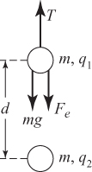

**ANS. FIG. P23.39**



**P23.40** From Example 23.2,the electric field due to a uniformly charged ring is given by



For a maximum, we differentiate *E* with respect to *x* and set the result equal to zero:



solving for *x* gives

or



Substituting into the expression for *E* gives



**P23.41** To find the force on the test charge at point *P*, we first determine the charge per unit length on the semicircle:

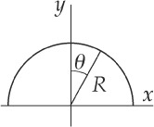

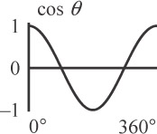

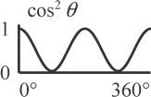

**ANS. FIG. P23.41**



or



which gives



The force on the charge from each incremental section of the semicircle is



Integrating,



Since the leftward and rightward forces due to the two halves of the semicircle cancel out, Fx = 0.

P23.42 Please review Example 23.3 in your textbook, emphasizing the Finalize section. There, it is shown that the electric field due to a non-conducting plane sheet of charge has a constant magnitude given by where is the uniform charge per unit area on the sheet. This field is everywhere perpendicular to the xy plane, is directed away from the sheet if it has a positive charge density, and is directed toward the sheet if it has a negative charge density.



In this problem, we have two plane sheets of charge, both parallel to the *xy* plane and separated by a distance of *z*0. The upper sheet has charge density while the lower sheet has Taking upward as the positive z-direction, the fields due to each of the sheets in the three regions of interest are:



|  |  |  |
| --- | --- | --- |
|  | Lower sheet (at z = 0) | Upper sheet (at z = z0) |
| Region | Electric Field | Electric Field |
| *z* < 0 |  |  |
| 0 < *z* < *z*0 |  |  |
| *z* > *z*0 |  |  |

When both plane sheets of charge are present, the resultant electric field in each region is the vector sum of the fields due to the individual sheets for that region.

(a) For *z* < 0,



(b) For 0 < *z* < *z*0 ,



(c) For *z* > *z*0 ,



P23.43 The field due to the point charge is uniform and points radially outward, so *.* The arc length of a small ring-shaped element of the sphere is *ds* = *Rdθ*, and its circumference is .

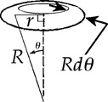

**ans. Fig. P23.43**



The area of the circular cap is



The flux is then



P23.44 Refer to ANS. FIG. P23.43 above. The field due to the point charge is uniform and points radially outward, so *.* The arc length of a small ring-shaped element of the sphere is *ds* = *Rdθ*, and its circumference  
is .



The area of the circular cap is



The flux is then



**Challenge Problems**

P23.45(a) Consider a cylindrical shaped gaussian surface perpendicular to the *yz* plane with its left end in the *yz* plane and its right end at distance *x*, as shown in ANS. FIG. P23.45.

Use Gauss’s law:



By symmetry, the electric field is zero in the *yz* plane and is perpendicular to over the wall of the gaussian cylinder. Therefore, the only contribution to the integral is over the end cap.

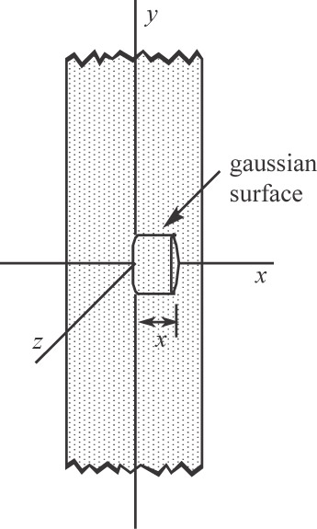

**ans. Fig. P23.45**



For ,



Then



or



(b) For ,



**P23.46** The resultant field within the cavity is the superposition of two fields, one due to a uniform sphere of positive charge of radius 2*a*, and the other due to a sphere of negative charge of radius *a* centered within the cavity.



**ANS. FIG. P23.46**

so



so



Substituting gives



Adding the fields gives



Thus, and at all points within the cavity.



P23.47In this case the charge density is *not uniform*, and Gauss’s law is written as We use a gaussian surface which is a cylinder of radius *r*, length , and is coaxial with the charge distribution.



(a) When *r* < *R*, this becomes The element of volume is a cylindrical shell of radius *r*, length , and thickness *dr* so that *.*



so inside the cylinder,



(b) When *r* > *R*, Gauss’s law becomes or outside the cylinder,



**P23.48** The total flux through a surface enclosing the charge *Q* is The flux through the disk is

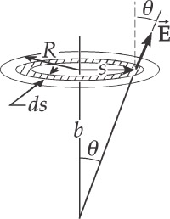

**ans. Fig. P23.48**



where the integration covers the area of the disk. We must evaluate this integral and set it equal to to find how *b* and *R* are related. In the figure, take to be the area of an annular ring of radius *s* and width *ds.* The flux through is .



The magnitude of the electric field has the same value at all points within the annular ring,

and



Integrating from *s* = 0 to *s* = *R* to get the flux through the entire disk,



The flux through the disk equals provided that .



This is satisfied if .



**P23.49** (a) The slab has left-to-right symmetry, so its field must be equal in strength at *x* and at −*x.* The field points everywhere away from the central plane. Take as gaussian surface a rectangular box of thickness 2*x* and height and width *L,* centered on the *x* = 0 plane. The gaussian surface, shown shaded in the second panel of ANS. FIG. P23.49, lies inside the slab. The charge the surface contains is . The total flux leaving it is *EL*2 through the right face, *EL*2 through the left face, and zero through each of the other four sides.



Thus Gauss’s law,



becomes

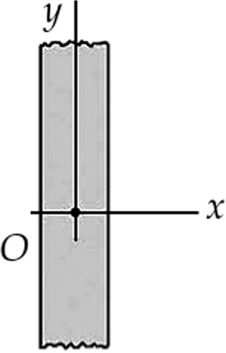

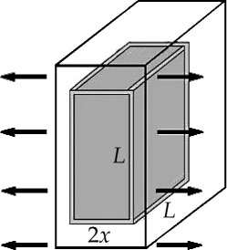

**ANS. FIG. P23.49**



so the field is



(b) The electron experiences a force opposite to When displaced to *x* > 0, it experiences a restoring force to the left. For the electron, Newton’s second law gives



Solving for the acceleration,



That is, its acceleration is proportional to its displacement and oppositely directed, as is required for simple harmonic motion.

Solving for the frequency, and



**P23.50** According to the result of Example 23.1 in the textbook, the left-hand rod creates this field at a distance *d* from its right-hand end:

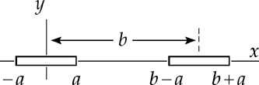

**ANS FIG. P23.50**



The force per unit length exerted by the left-hand rod on the right-hand rod is then



Integrating,



P23.51 (a) We call the constant *A’,* reserving the symbol *A* to denote area. The whole charge of the ball is



To find the electric field, consider as gaussian surface a concentric sphere of radius *r* outside the ball of charge:

In this case,



Solving,



and the electric field is



(b) Let the gaussian sphere lie inside the ball of charge:



Now the integrals become



Performing the integration,



and the field is



|  |
| --- |
| **ANSWERS TO QUICK-QUIZZES** |

**1.** (e)

**2.** (b) and (d)

|  |
| --- |
| **ANSWERS TO EVEN-NUMBERED PROBLEMS** |

P23.2 See ANS. FIG. P23.2.

P23. 4



P23. 8 (a) (b)



P23. 10



P23. 12 *chw*2/2

P23.14



P23. 16 (a) ; (b) ; (c) The answer to part (a) would change because the charge could now be at different distances from each face of the cube. The answer to part (b) would be unchanged because the flux through the entire closed surface depends only on the total charge inside the surface.



P23. 18 (a) ; (b) ; (c) no



P23. 20



P23.22 (a) The net flux is zero through the sphere because the number of field lines entering the sphere equals the number of lines leaving the sphere; (b) The net flux is 2*πR*2*E* through the cylinder; (c) The net charge inside the cylinder is positive and is distributed on a plane parallel to the ends of the cylinder.

P23. 24 2.33 ×1021 N/C

P23.26 (a) ~10–3 N or 1 mN; (b) ~10–7 C or 100 nC; (c) ~10 kN/C;   
(d) ~



P23. 28 (a) 4.86 × 109 N/C away from the wall; (b) So long as the distance from the wall is small compared to the width and height of the wall, the distance does not affect the field.

P23.30 (a) –*Q* (b) yes

P23. 32 (a) ; (b) 1.33 × 10–10 C; (c) No; fields on the faces would not be uniform.



P23.34 (a) +913 nC; (b) 0

P23. 36 (a) (b) Yes, it is possible for one specific value of *r*, .



P23.38 (a) 2.00 × 10–10 C; (b) 1.41 × 10–10 C; (c) 5.89 × 10–11 C

P23. 40



P23.42 (a) $+\frac{σ}{2ε_{0}}$ (b) $+\frac{3σ}{2ε_{0}}$ (c) $-\frac{σ}{2ε_{0}}$

P23. 44



P23.46



P23. 48



P23.50

